Science Center Library and Circulating Repository

The Needham Science Center has books (for both adults and children), curriculum and activity guides, live animals, kits, exhibits, models, class book sets, games, videos, sound recordings, models, “big books”, posters, and equipment which can be circulated to teaching staff within the Needham School District.

Items in our collections emphasize inquiry-based learning techniques and provide many specific ideas and programs to enhance science literacy in and around the classroom. We also have publications related to professional growth and leadership, general education theory, and curriculum content and strategy in areas of science, mathematics, engineering, ELL, poetry, and literacy.

Items are described and indexed in a convenient catalog that can be accessed by clicking this link and then choosing the “Science Center”.

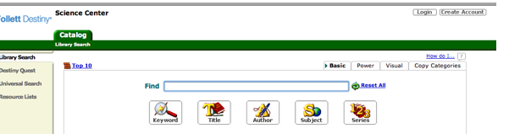

You can then search by keyword, title, subject, or author. You can also create a “Resource List” of items which you have chosen from the database.

Choose “Create Account” and input your last name and barcode (you can get your barcode by contacting the Science Center). Items can then be requested by clicking on the “Hold it” button; if the item is in we will send it to you within two days. Once you have created your own account you can also access the “public lists” category to see lists which have been created by Science Center staff to alert you to special categories.

If you have any questions regarding specific topics or publications, you are welcome to call the Science Center at 781-455-0475 and speak to a staff member directly. We continue to add items weekly; if you don’t see something, feel free to ask.

NOTE: Live animals and class kits do not appear in the database. In order to request these materials you must contact the Science Center by phone 781-455-0475 or email sciencecenterrequests@needham.k12.ma.us

